How to Observe and Measure a Spiral-Antenarrative?
David M. Boje, Ph.D.
New Mexico State University, 8/29/2011; revision 9/2/2011
ABSTRACT
The purpose of this essay is to develop a method for the diagnosis of spiral-antenarratives that are ontological, not just theoretical. An antenarrative is a conception I invented in 2001 (Narrative Methods...) book. An antenarrative is active ‘before’ [1st meaning of ante] to coherent or petrified narrative, and is a ‘bet’ [2nd meaning of ante]. Since then, I have developed an interest in ‘anteriority’ [3rd meaning of ante], which I find more to do with the nature of spiral-antenarratives that are in-Being, in authentic manner that is factical. The factical spiral-antenarrative manner of caring for donors, customers, employees, and so forth in the life that is being-placed into a spiral-antenarrative-world, where they are attended to, and in dealings with them in the everydayness of spiral-antenarrative that is concerned, caring, and in-order-to, is awake, and primordial, rather than just being theoretical-spiral. For the Diagnosis of Spiral-Antenarrative, ask ontological questions while tarrying for a while in situ: “What is it, this spiral?” “What is it for?” What are we supposed to do with spirals?” Who is the spiral for?” “What is the spiral supposed to be? And “Who made this spiral-thing?”
INTRODUCTION
We must take care to not just do the traditional research practice and invoke a theoretical-spiral-as-schema using abstract-time (clock-time) and abstract-space (with no there-ness). Martin Heidegger’s (1999/1923) Ontology—The Hermeneutics of Facticity was a summer lecture given in 1923, and published in English in 1999. Here I apply ontology to spiral-antenarrative. Spiral-antenarrative in its ‘anteriority’ is defined here as “being-there” in spatiality and temporality that is primordial, rather than some concept of time, such as container-inside-contain space, or clock-time where the hands of the clock move through the space of clock-face (ibid, p. 72). Antenarrative has four senses of ‘ante.’ The essay is defining terms and coming up with a practice of diagnosis of spiral-antenarratives that is ontological, facticity.
The practical part of how to observe and measure spirals begins with developing a visual that gets as close as possible to the phenomena of adaptive emergence and risk assessment as possible. The explication of the visuals will sort through the process changes from one twirl to the next, and give us some collective sense of how its future appears to be portending. IN working with New Mexico Military Institute and its key areas of Foundation and Alumni Association, we anticipate there are some degrees of freedom within what is unfolding, to enact projects of change that are helpful.

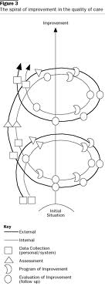
The above drawing could represent Alumni Association and Foundation as they each have their spiral paths, and change processes slightly or in dramatic ways in each twirl-repetition. Comparing from one twirl to the next gives a sense of trajectory of the flux and changes. At each episodic event, there is a field of forces, that both constrain, and open up possibilities within degrees of freedom.
I notice in the book, New Mexico Military Institute: A Centennial History, Gibbs and Jackman (1991) depict a series of events, a path that is changing, such as New Directions 1947-1951, Turmoil and Tradition, 1951-1955, Good Times 1963-1966, Difficult Years 1966-1971, Renaissance, 1971-1976 Females and Adjustment Years 1976-1981, Stability and Material Development 1981-1986. I am going to ask Tiffany and Patrick, to read the Centennial History with me and sort out a visual presentation and a historicalness of the spiral.
The Practical Steps: The way to begin: Ask these eight questions, each one of them, multiple times.

- “What is this process?” Describe it, and ask again.
- “How is that process now?” Explicate it, and ask again
- “What is this process for?” This is the in-order-to question
- What are we supposed to do with this process?” This is your role in the process of changing the process
- Whom is the process for?” These are the constituents/stakeholders
- “How is the process supposed to be? This is the ideal way it would/could/should/ought to be
- “Who made this process?” This gets at the historical, and ask it multiple times
- “How did it come to be as it is?” This is the deeper historical, and gets at the co-evolution forces and changes the process has undergone, and is undergoing.
By answering the eight questions, you get the following understanding of flux and flow as multiple forces of change and intra-play affect the process you attend to, and are caring about.
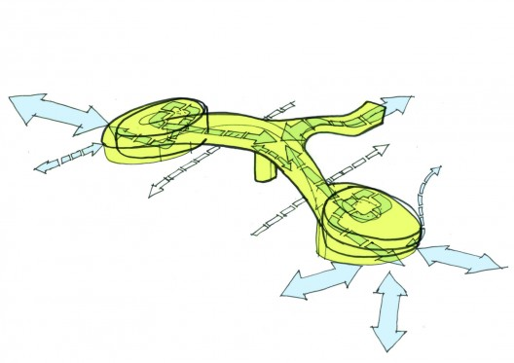

Perhaps an image such as these will help. It’s always good to look at several ways. This next one is the spiral of Foundation Giving:
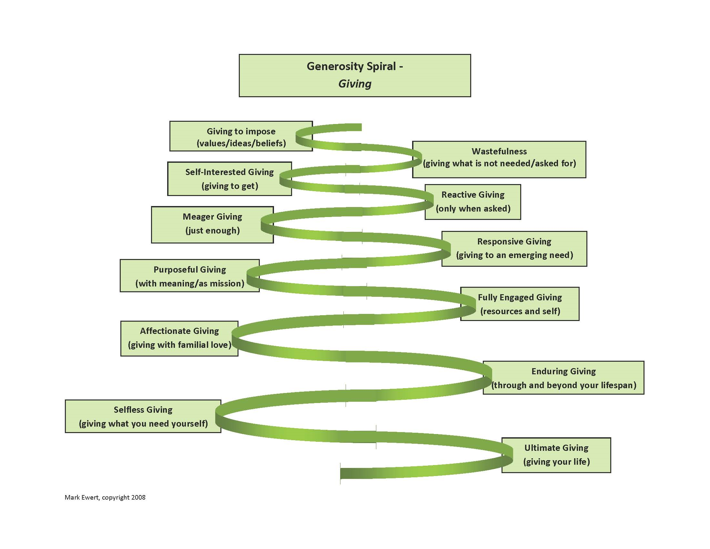
http://www.generositypath.com/blog/wp-content/uploads/2009/02/generosity-spiral-giving.jpg
It is problematic, in that it presupposes lots of symmetry, in the spiral is amplifying, twirl-by-twirl. In the trade, we call this a progress myth, the illusion of every-expansion, without setback.
Next are charts from the Petty Foundation. They depict more measurement and mathematical precision.
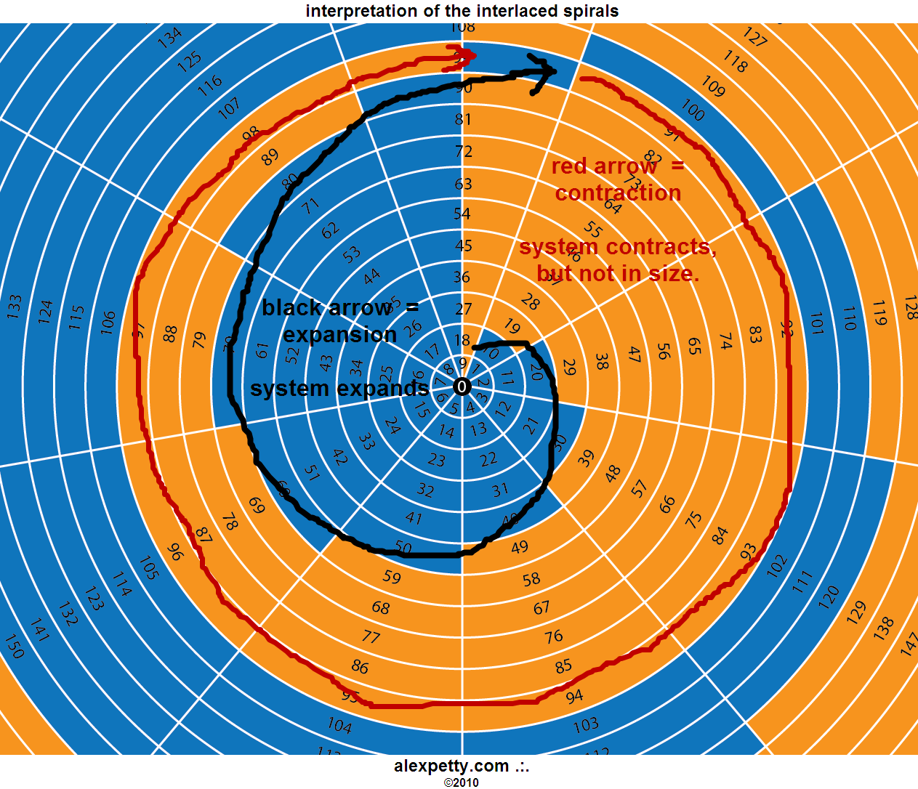
http://www.alexpetty.com/2010/01/09/the-true-foundation-of-arithmetic/
For example: “The numbers set themselves up as interlaced spirals. The Yin spiral expands the system. The system grows as large as it can in as it moves through 2 Pi along the spiral path. When it reaches 2 Pi (at 9), the system begins a kind of contraction, not in size but in movement back towards the initial polarity. It seems the system that governs creation, which is reflected by mathematics, never loses size once gained.”

Risk analysis spiral – This is important because in making process improvements, there are risks to be assessed.
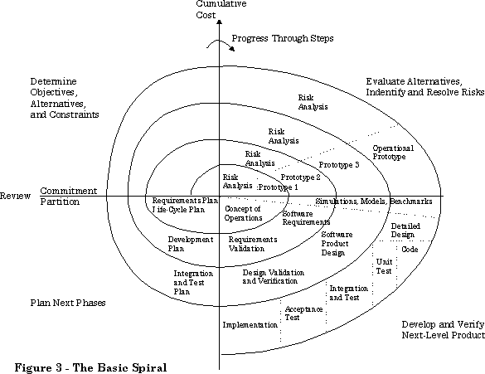
http://dwaynephillips.net/CutterPapers/Vshape/fig03.gif with explanation of how to develop a v-shape spiral at http://dwaynephillips.net/CutterPapers/Vshape/spiral.htm

I hope by this point you get the idea that a basic basic Plan-Do-Check-Act though sometimes called a spiral, is really just a cycle that repeats. http://www.cmcrossroads.com/bradapp/docs/i-spi/spiral.gif that is actually a cycle versus this next one which is a spiral of improvement-research-action that focuses on shifts in context, not just an abstract plan-do-check-act schema. The theory is: Giles Deleuze (1994: 21) says, “Cycles are only abstractions: places to together they reveal evolutionary cycles [dynamic repetitions] or Spirals [that do not repeat cycle of sameness-repetitions] whose principle is a variable curve and the trajectory of which has dissymmetrical aspects as though it had a right and a left" (bracketed editions, mine). Here is a risk assessment example:
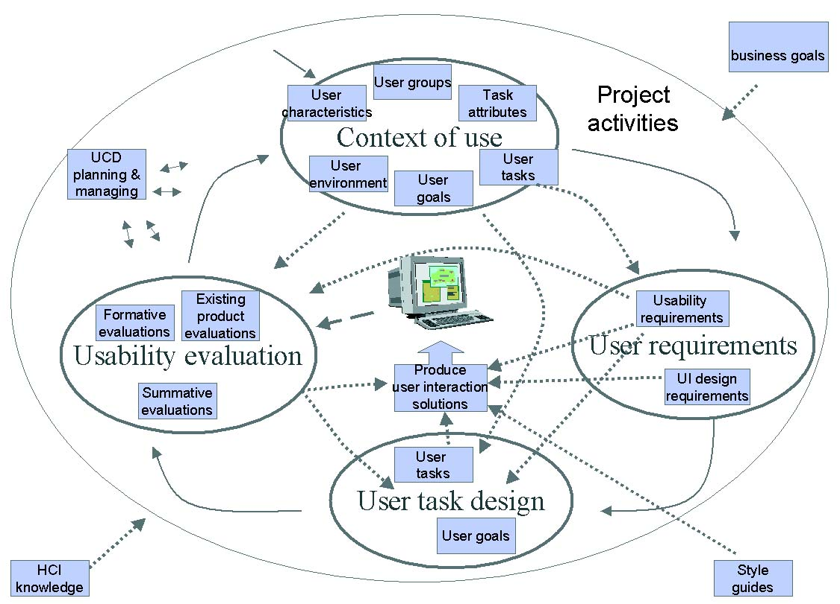
http://www.infotech.oulu.fi/Annual/2000/pics/SPIRAL_0.jpg see explication http://www.infotech.oulu.fi/Annual/2000/SPIRAL.html

Imagine your organization as going through three waves, as in the case of this education institution:
“The first wave of school reforms and initiatives focuses mainly on internal quality assurance and makes an effort to improve internal school performance, particularly the methods and processes of teaching and learning. The second wave emphasizes interface quality assurance in terms of organizational effectiveness, stakeholders’ satisfaction and market competitiveness and makes an effort to ensure satisfaction and accountability to the internal and external stakeholders. The coming improvement initiatives should be moving towards the third wave, which emphasizes strongly future quality assurance in terms of relevance to the new paradigm of education concerning contextualized multiple intelligences (CMI), globalization, localization and individualization.”
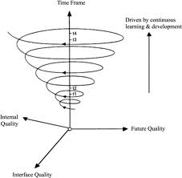

At each event horizon, there is a set of forces.
The point of the socioeconomic approach to management that students in the small business seminar are learning is to develop projects that improve processes while engaging in risk and cost analysis. First this means looking at simultaneous forces of change
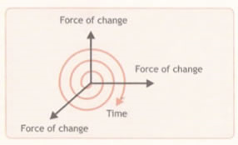Second in means assessment of deeply rooted risks (stem-roots as we call them).
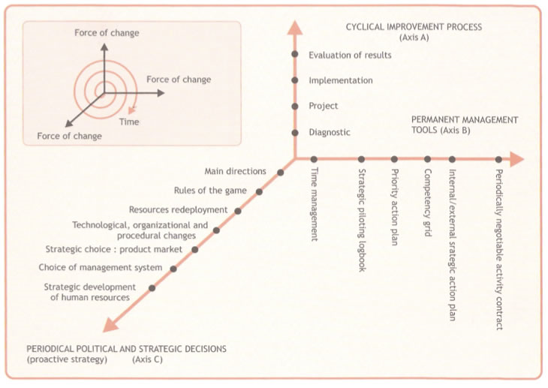
SEAM 3 Axes of Socio-Economic Intervention Research (Source, Savall, Zardet, & Bonnet, 2008: 26).

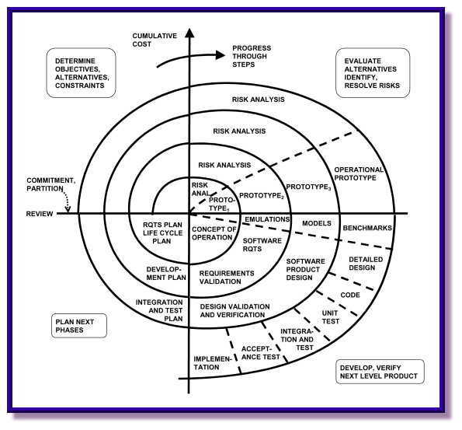

Next, we look at basic definitions for getting from schema to actual ontological aspects of processes.

PART I: DEFINING KEY TERMS IN THE SPIRAL-ANTENARRATIVE DIAGNOSIS
What are the meanings of Ante in Antenarrative?
- Ante that is ‘before’ narrative coherence and petrification sets in, doing all that emptying out of living story. Suitable for linear-plots, the beginning, middle, and end-state (predicted) (see Boje, 2001a)
- Ante that is ‘bet’ of transformation, the prediction of some stage-by-stage cycle, but more in theory than in practice (Boje, 2001a, 2011a).
- Ante that is ‘anteriority’ such as the anterior of spiral, its futurity, ahead of itself, future encountered in emergent present, rather than in retrospective past accumulation of past-nows swelling in the present (as Bergson puts it, and as Heidegger disagrees) (Boje, 2011b, c, d)
- Ante that is ‘a priori’ in the Kantian sense of a transcendental. In the examples of Kantian spatiality and temporality that are a priori to Being-there (Boje, 2011b, c, d).
Here, in this essay, we focus on ante in its anteriority. Spiral-antenarratives [ante-in-the-anteriority-sense] are ontological paths, being-in-a-spiral-world and being-within-a-spiral-world while all the while being concerned, and in-caring of the encounters “putting in place, directing ourselves to task, taking into possession, protecting, protecting against loss, etc.” (Heidegger, 1099: 79, capitalization mine).
What is the character of the Spiral-antenarrative? In socioeconomic and quantum diagnosis, gaining familiarity by the encounters with spiral and its disclosedness comes from tarrying for a while, and asking the questions: “What is it?” “What is it for?” What are we supposed to do with it?” Who is it for?” “What is it supposed to be? And “Who made it?” this spiral-thing (ibid, p. 72). Such disclosedness comes by attending to a multiplicity of relations, such as we attempt in the socioeconomic approach to consultation, to diagnosis, and intervention (Savall, Zardet, & Bonnet, 2008). The habits of being are there, for “beings-which-are-there” in spiral, and “on the being of this disclosedness” (ibid, 72). That is not a priori (a 4th meaning of ante, a Kantian meaning), not apart from but is “in order to do something” where this disclosedness resides (in anteriority, the 3rd meaning of ante). This diagnosis depends on you, the consultant/researcher ‘being-there” in the everydayness encountering spiral-antenarrative in its spacetimemattering. It means ‘tarrying-for-a-while’ in the “disclosedness of what is being encountered—the in-order-to, the fore-whom, the from-whom, etc.—is NOT encountered in the familiarity of the everyday (the possibilities of familiarity are factical historical), where something strange presses into the world closest to us and we happen to access it” (Heidegger, 1999: 72).
What is Facticity? Facticity is defined as the factical spatiality and the factical temporality that is primordial rather than a theoretical-schema used in research to make deductions. Facticity is also caring about something, attending to something, and being concerned for something. The factical life of a small business or larger institution, in the being-there, of forehaving (defined below), involves making a choice between a forehaving that is just a theoretic schema, and a forehaving that comes form diagnosis in situ, being-there, in a place, at a particular time, and engaging in a “path of looking” (ibid, p. 62). The path of the spiral, its many twirls, is not a symmetrical one, except in abstract geometry. We hope in diagnosis to illuminate a certain spacetimemattering “stretch of the path of inquiry” by “seeing along a path” of a passage of twirls that make up the spiral. The being-there is accompanied by the spiral-antenarrative being-interpreted, in all its directionality, its ups and downs, and ins and outs, and with a strong sense of caring about something, in-order-for-something. The primordiality of the spiral-antenarrative is defined by genuineness of forehaving that is ground in being rather than geometric, in factical life of spiral being-there, and being-here.
What is Spatiality? “Spatiality, which is saturated in a factical manner with concern, has it distances” and in the spiral the twirls each “round-about” is defined primordially as “being-location-side-by-side-and-around-each-other” as twirl around twirl in an everyday context of ‘environs’ in the ‘authentic sense; of spiral “being-in-such-and-such-a-manner” (ibid, 78) and in a disclosedness and “fore-having of caring” (ibid, p. 72).
What is Temporality? ‘Temporality’ that is primordial is not mere ‘clock-time’ or ‘world-time’ of the planets circulating. “Temporality: there from that time for, during, for the sake of” (ibid, p. 72). The spiral “paths of being concerned with and attending to: in the “everydayness and its historicity” is not a theoretical time (ibid, p. 72). Primordial temporality is a for example being-of-concern, and being-attended-to, and in-order-to, with a “multiplicity of references” and “caring as a going about dealing” with donors, customers, employees, suppliers, etc. (ibid, 78).
What is a Spiral-mattering? “Spiral-mattering’ is defined here in a quantum sense of mattering. For Karen Barad (2003, 2007) spacetimemattering is not three things in separation, and in the quantum physics the mattering is inseparable from spacetime, therefore ‘spacetimemattering’. The spacetimemattering of a spiral, its mattering, in the primordial sense of quantum-mattering, is all about interconnectivity of everything. Spiral paths of interconnected being, the primordial of concerned and caring, is in the very disclosedness of quantum-mattering. The ‘spiral-thing’ in its disclosedness, in its “availability in advance” and being-about-and-around the ‘with-world’ of “there-in-order-to-do-this” to care for that, to ‘be occupied with´ and “being-there-for-this” in the spiral-thing is “something disclosed” in mattering, (ibid, p. 71), in the “primordial being-real” (ibid, p. 69).Doing diagnosis in the “phenomenal context” of spiral-mattering, is defined as tending to the in-order-to-do-something of the spiral-antenarrative. It is not a “constructivistic” with social constructivism “prejudices” (ibid, p. 69) that does not allow for materiality, or for mattering, and is rather self-restrictive to the sensemaking of language, or discourse, of just the five-senses, the sensory (see Barad, 2003, 2007; Latour, 2005). In Barad’s version of quantum physics, there is an ‘intra-penetration’ or ‘intra-activity’ of discourse with the quantum materiality. Here we look at storytelling as one domain of discourse (along with trope and metaphor) and its intra-penetration ‘with’ materiality, all that spacetimemattering with storytelling.
What is forehaving? ‘Forehaving’ has two modes. There is the forehaving by an abstract (theoretical) schema of the spiral, where the quest for objectivity is a standpoint outside of primordial time, space, and mattering. Then there is the primordial “awhileness of temporal particularity” (ibid, p. 65) and spatiality that is primordial, and the “possibility of authenticity” that is not covered up by the schema (ibid). In Part II, we will look at the first and second mode of forehaving in trying to draw spirals. The “schema” must be avoided, for all its symmetry, its an “ego-pole” (p. 62), that is a “constructivistic forehaving” from the “sedimented tradition of geometric symmetry that “obstructs access” to the spiral-antenarrative’s “factical life” (ibid, p. 63). This is what Heidegger calls the “epistemological problem” of knowing, which can be quite “wrongheaded” and reduce problems into “psequdo-problems” in acts of social constructivism (ibid, p. 62).
What is Storytelling? ‘Storytelling’ is defined as a domain of discourse, with three inter-playing genres: retrospective narrative, living story webs of relationality, and four sorts of antenarrative (linear, cyclic, spiral, & assemblage-rhizomes) (for more on this see Boje, 2011a). In this essay our focus is on spiral-antenarratives, how to diagnose, research, and intervene in them, in the once-occurrent event-ness of Being-ness. Since spiral-antenarratives, are not theoretical, but ontological, we ‘tarry-for-a-while’ and ‘encounter-them’ in spacetimemattering, in the primordial sense of spiral, not in its abstraction, its theory, or some geometric schema? Heidegger (1999: 67) is against the sort of storytelling that is transcendent of factical primordial ontology. The “so called experience” we now call sensemaking, or storytelling-sensemaking is not getting at “authentic analysis” that is ontological (ibid, p. 67). But the sensory-experience (aka cognitive) is still for Heidegger (1999: 67-8) “still superior to all those theories that tell stories about the transcendence of objects and reality without even having taken a look at the matters so valiantly written about.” Therefore, I am advocating a particular sort of analytic storytelling, that is not theory, not sensemaking-experience, but is spiral-antenarrative, in all its anteriority of a material (quantum) thing in spatiality and temporality that is primordial. The spiral-antenarrative “glows in a continuous manner into other aspects stretched out in advance in the spatial gestalt of the thing: we are calling spiral-antenarrative, which is very much a quantum-thing (Heidegger, 1999: 68). To me, this is the fractal nature of spiral-antenarrative.
What is Familiarity? It is not a theory of familiarity, but actual factical manner of familiarity, in particular context of spatial and temporal references, such as the referential signifiers of the factical manner of the particular context, particular time, and encounters in place, of spiral-antenarrative, that is “around for a while” and those donors, customers, employees, and so forth, the “beings-which-are-there themselves, being ‘in” the spiral, “placed in concern” and caring, being attended to (ibid, p. 78).
What is Fore-care? ‘Fore-care’ is defined here as all the habits of action, thought, and emotion in working, being occupied in everydayness of spiral, its ‘where to” of “being out-for and going-toward: fore-care and its ‘about: what it goes ‘around’ in” the “authentic character” of spiral we encounter in being-there (ibid, p. 75). Donors, and alumni, of an education institution, for example, are encountered in everydayness, “those-who-are-there-with-us in everydayness” and are not isolated in some theoretic out there, but are wither in spiral “with-world: of “factical lives” the spiral “has something to do with” (ibid, p. 76).
How to Observe and Diagnose Spiral-Antenarratives? Have encounters, the spiral-thing being encountered in the everydayness of the organization and its environs, by being-there, in situ. This method of encounter is about not just familiarity but disclosedness. The “ascertainability”of spiral is not just its ontic (being-or-not-being), but is rather the how of its ‘being-there’ and “tarrying-for-a-while” as an observer and participant in the spiral-antenarrative, noticing its disclosedness.
What is Disclosedness? ‘Disclosedness’ is defined here as the spiral’s being ahead of itself in an “availability in advance” and the “advance appearance of the with-world” of that spiral that is “useful for” and importance for, “being-there-for-this” out of concern for “beings-which-are-there” in caring for all kinds of donors, alumni, students, employees, and so forth in the example of a university (ibid, pp. 75-6). Disclosedness has special and temporal particularity, a factical primordially-encountered-spiral, “what is being encountered” (ibid. p. 73).
Next, in part II we turn to the particulars of the diagnosis.
PART II: Making the Spiral-Antenarrative Diagnosis
Ask these questions: “What is it, this spiral-antenarrative?” “What is it for?” What are we supposed to do with spirals?” Who is the spiral for?” “What is the spiral supposed to be? And “Who made this spiral-thing in all its spacetimemattering?”
Tell a spiral-antenarrative of the organization, beginning at its first encounters with its environs, and noticing, the in-order-to, the caring-for-whom, and being-concerned-for-things. A spiral is not linear (ABCD). It is not the repetition of sameness as in the cyclic-antenarrative, with stage-by-stage that do not change and have no flux, are just petrified circles, in the theoretic, in the abstract.
Here is what could be mistaken as a spiral, but is actual the repetition of sameness cycles, in cycle time. It is a very common error.
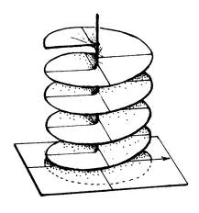The next one is a spiral, but with symmetric increase in each rotation There seems to be a strong human urge for symmetry in spirals. This next one is more dynamic-spiral or this next one, a bit more chaotic-spiral
These are still more schema than what one finds in an actuality of a socioeconomic situation. A schema of a theory of spiral can do more harm than good, for a diagnosis. If you must sketch out a spiral, realize that its spacetimemattering cannot be drawn. If you must draw a spiral-antenarrative, try the following:
- Draw the top view of the spiral – but not like these two: try to get beyond the schema of a symmetrical spiral. Try this next one 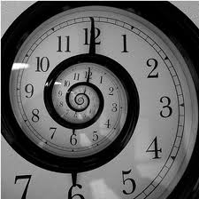Next one is symmetric, so we are not there yet
Note the differences in these top-view spirals 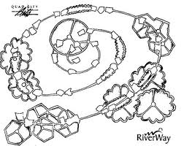 – try to draw yours in the temporality-of-everydayness by writing up the observations not by uncritical experience, but in a mode of in situ Being-there, “primordial being-real” (Heidegger, 1999: 69).
- Draw the bottom view of the spiral. Add some variations, and get at the non-symmetricality Look at the spiral from below, as it moves along a trajectory, a path of its wholeness.
Next are side-views – This one has labels of era-by-era is a sort of progress mythic of evolution
- Draw your own side view of the spiral you are encountering with your client – 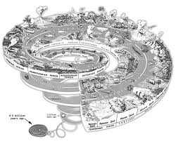 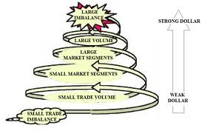 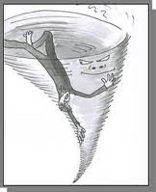 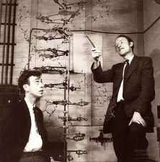 all its twirl-by-twirl dynamic-repetitions, each a bit different than the last, in-order-to-do-something. In the trade, one says continuous improvement, meaning in each repetition of a twirl, there are improvements, or without care, there are deteriorations (more dysfunctions). Draw in the stratums of being-spiral the ‘with-world” of one event then another, but ones, that shift the direction, up or down, or inward or outward, as the spiral lifts from its starting events into what you encounter now, and continue drawing where, in its ‘ahead-of-itself’ the future is chiming into the present, caring about this or that, a concern for others.
- Next draw the fractal nature of spiral-antenarrative. In the Mandelbrot fractal-spiral, there are budding, branching spirals forming off the main roads of the spiral, and it’s very much a gestalt of the spiral, its flows in a continuous manner, effecting and affected by directions that show themselves as being-there, in anteriority.
Here are a few drawing
Try moving away from theoretic-geometric schema to a manner of spiral-antenarrative.
In conclusion, the diagnosis of spiral-antenarrative is in the direction of encounters, in a concrete situation, of factical spacetimemattering. The research of the encounters in situ gets beyond sensemaking-experiences, to analytic thinking about the how of Being-there of the spiral. It is a matter too of moving away from tiered stereotypical schema of spirals where symmetry demands emptying out the diversity and variations. Tarrying-for-a-while in the situation, its everydayness, focusing on historicalness and on the future ahead of itself lets us approach an authenticness of everyday spiral-being-encountered.
The spiral-antenarrative is something being encountered in the everydayness of the environing world of the organizing of the work-world in the “world round-about” as encounters of natural world and consumption world occur in the factical life in the forehaving and forecaring (Heidegger, 1999: 65-6). The spiral-fractals are making, forehaving all sorts of references in the environing world in the “how of being-of-concern” and the “attending to” of the spiral-antenarrative itself, in its “primordial interpretation” and ethic of caring-about-something-being-there as well as what is spiral-living-form of “from out of the world” the environs (ibid, p. 65).
References
Bakhtin, M. M. (1990). Art and Answerability. Editied by Michael Holquist & Vadim Liapunov. Translation and Notes by Vadim Liapunov; supplement translated by Kenneth Brostrom. Austin, TX: University of Texas Press. From Bakhtin’s first published article and his early 1920s notebooks.
Bakhtin, M. (1993). Toward a philosophy of the act (translation and notes by Vadim Liapunov; Michael Holquist and Vadim Liapunov, eds). Austin, Tx, University of Texas Press.
Barad, K. (2003). Posthumanist performativity: Toward an understanding of how matter comes to matter.” Journal of Women in Culture and Society. Vol. 28 (3): 801-831). On line at http://www.kiraoreilly.com/blog/wp-content/uploads/2009/06/signsbarad.pdf
Barad, K. (2007). Meeting the Universe Halfway: Quantum Physics and the Entanglement of Matter and Meaning. Durham: Duke University Press.
Barad, K. (2011). Erasers and erasures: Pinch’s unfortunate ‘uncertainty principle.’ Social Studies of Sciences, Vol. 41 (3): 443-454.
Benjamin, Walter. (1999). The Arcades Project. Translated by Howard Eiland & Kevin McLaughlin. Cambridge, MASS: Harvard University Press.
Biggs, William E.; & Jackman, Eugene T. (1991). New Mexico Military Institute: A Centennial History. Roswell: NM: The NMMI Centennial Commission. ISBN: 0-9630997-1-X.
Boje, D. M. (1991a). ‘Consulting and change in the storytelling organization’. Journal of Organizational Change Management, 4, 3, 7–17.
Boje, D. M. (1991b). ‘The storytelling organization: a study of story performance in an office-supply firm’. Administrative Science Quarterly, 36, 1, 106–26.
Boje, D. M. (1994). ‘Organizational storytelling: the struggles of premodern, modern and postmodern organizational learning discourses’. Management Learning, 25, 3, 433–61.
Boje, D. M. (1995). ‘Stories of the storytelling organization: a postmodern.
Boje, D M. (1998). ‘The postmodern turn from stories-as-objects to stories-in-context methods’. Research Methods Forum, No.3 (Fall 1998), p. 1-8 http://www.aom.pace.edu/rmd/1998)_forum_stories.html
Boje, D. M. (2001). Narrative Methods for Organization and Communication Research. London: Sage.
Boje, D. M. (2007a). Chapter 13 Living Story: From Wilda to Disney, pp.330-354. Handbook of Narrative Inquiry: Mapping a New Methodology. Edited by Jean Clandinin, London: Sage.
Boje, D. M. (2008a). Storytelling Organizations, London: Sage.
Boje, D. M. (2008b). Critical Theory Ethics For Business and Public Administration. Charlotte, NC: Information Age Press.
Boje, D. M. (2011a). Storytelling the Future of Organizations: An Antenarrative Handbook. London: Routledge.
Boje, D. M. (2011b). Quantum Physics of Storytelling (download entire book PDF here). Please check each week, as book is being written day by day.
Boje, D. M. (2011c). Reflections: What does Quantum Physics of Storytelling Mean for Change Management? Journal of Change Management, accepted 7/22/2011, waiting to appear in print in 2012.
Boje, D. M. (2011d). Quantum Physics Implications of Storytelling for Socioeconomic Research Methods: Experiences in Small Business Consulting Research from New Mexico State University. Paper presented to the International meeting of Research Methods Division of Academy of Management, in Lyon, France, June 15 2011. Published in the Proceedings of the conference. Click here for pre-publication pdf.
Boje, D. M. (2011e). A Subtler Quantum Physics for ‘Storytelling Organization’ Theory, Method Practice. Conference Proceedings of the Standing Conference For Management and Organizational Inquiry in Philadelphia, April 13-16, 2011. Editor Donna Carlon.. See preproceedings draft version.
Boje, D. M. (2011f). Antenarrative Time, Space, and Matter in Teleological Causality:
Thanking Hugo Letiche for His work on Bergson. University for Humanistics, DBA Methodology Workshop: Storytelling and Narrative in Organizational Research, 19th April, Utrecht, Netherlands. Preconference version of the presentation.
Deleuze, G. (1994). Difference and Repetition. Translated by Paul Patton from French, 1968 text, Difference et Repetition (Presses Universitaires de France). NY: Columbia
Deleuze, G. and Guattari, F. (1987). A Thousand Plateaus: Capitalism and Schizophrenia. Minneapolis, MN: Univ Of Minnesota Press.
Harvard Graduate School of Education (2008). Six types of causality. http://www.cfa.harvard.edu/smg/Website/UCP/causal/causal_types.html
Heidegger, M. (1962) Being and Time. Translated by John Macquarrie & Edward Robinson. NY: Harper Row.
Heidegger, M. (1992). History of the Concept of Time: Prolegomena. Translated by Theodore Kisiel. Bloomington & Indianapolis: Indiana University Press.
Heidegger, M. (1999). Ontology – The Hermeneutics of Facticity. Translated by John van Buren. Bloomington & Indianapolis: Indiana University Press.
Heidegger, M. (2003). Four Seminars. Translated by Andrew Mitchell and Francois Raffoul. Bloomington & Indianapolis: Indiana University Press.
Kant, Immanuel (1781/1900). Critique of Pure Reason. Translated by J. M. D. Meiklethohn, with introduction by Meiklejohn, and also by Brandt V. B. Dixon. NY: The Colonial Press. See online version, http://philosophy.eserver.org/kant/critique-of-pure-reason.txt
Kitarō, Nishida. (1970/1933-4). Fundamental Problems of Philosophy: The World of Action and the Dialectical World. Translated by David A. Dilworth. Tokyo: Sophia University. Translated from two volumes of his Japanese writing he did 1933-1934.
Kitarō, Nishida. (1987/1917). Intuition and Reflection in Solf-consciousness. Translated by Valdo H. Vigielmo, with Takeuchi Toshinori and Joseph S. O’Leary. NY: State University of New York Press. Translated from his writing done in 1917.
Kitarō, Nishida. (1990/1911). An Inquiry into the Good. Translated by Masao Abe and Christopher Ives, with introduction by Abe. New Haven/London: Yale University Press. Translated from the 1911 Japanese text.
Morin, E. (2008). On Complexity. Translated by Robin Postel. Cresskill, NJ: Hampton Press, Inc.
Savall, H.; Zardet, V.; & Bonnet, M. (2008). Releasing the Untapped Potential of Enterprises Through Socio-Economic Management. Geneva, Switzerland: ILO (International Labour Office) Bureau of Employers’ Activities.

